Winterbourne Medieval Barn Access Information

Introduction
Winterbourne Medieval Barn welcomes Deaf and disabled visitors. We are a small team, largely made up of volunteers, and we are constantly learning how we can best support visitors to our historic site. We hope that this document will give you the information you need to plan your visit, but we welcome feedback, and are more than happy to discuss how we can support your visit.

Contact Details
For more information or to discuss your visit please contact Ceara Foley – Community Events Coordinator, or the Venue Manager
Ceara.Foley@winterbournebarn.org.uk
Venue.manager@winterbournebarn.org.uk
0117 403 15 36
We work part time, and sometimes remotely, so it is best to email if you can. If you’d prefer to call, please leave a voicemail. We will reply as soon as we can, but it could take us up to a week to get back to you.

Venue Description
Winterbourne Medieval Barn is largely step free, but there are uneven floor surfaces throughout. The Main Barn, Box Office/Foyer area, and toilets are all on the ground floor and have step-free access. Our bar is only open at certain events which will be advised in the pre-event email. The bar is in a space with a very uneven floor, and has a small, steep ramp to access the space. The Byre Workshops are accessed via a lawn. There is a permanent ramp to access the Byre Toilets.

Bookable Facilities
For larger events our car park is for blue badge holders only and spaces must be booked in advance. For smaller events such as workshops the car park is available to all attendees, but we recommend getting in touch to reserve a space so we can ensure an appropriate parking space is reserved for you. There are two accessible parking bays.
We do not have reserved seating for our events. We are very happy to reserve seats or areas for individuals and the rest of their group to help with access. Please get in touch in advance so we can arrange this for you.
Disabled people and one carer are both eligible for concession tickets.

Travel Guide
There is more detail on accessible parking in the ‘bookable facilities’ and ‘Arrival Guide’ sections.
Taxis are welcome to drop off in the car park, see ‘arrival guide’ for more information
The Barn is unfortunately not directly serviced by public transport. The nearest bus stop is in Winterbourne near to the Co-Op, and the nearest Train station is Bristol Parkway.

Arrival Guide

Car Park and Box Office

The venue is typically open from 30 minutes before the start of an event. You will receive an email with more information a day or two before the event.
There is likely to be a volunteer stewarding the car park when you arrive. They should have your vehicle registration, but they may stop you to confirm you have booked a space. The steward will direct you where to park.
There are two accessible parking bays. For most large events only staff, performer, and blue badge parking is on site. Parking needs to be reserved. Please let us know if you need one of these to bays, or if a standard parking space is suitable.
Taxis and carers can drop off at the end of the path and then park if needed.

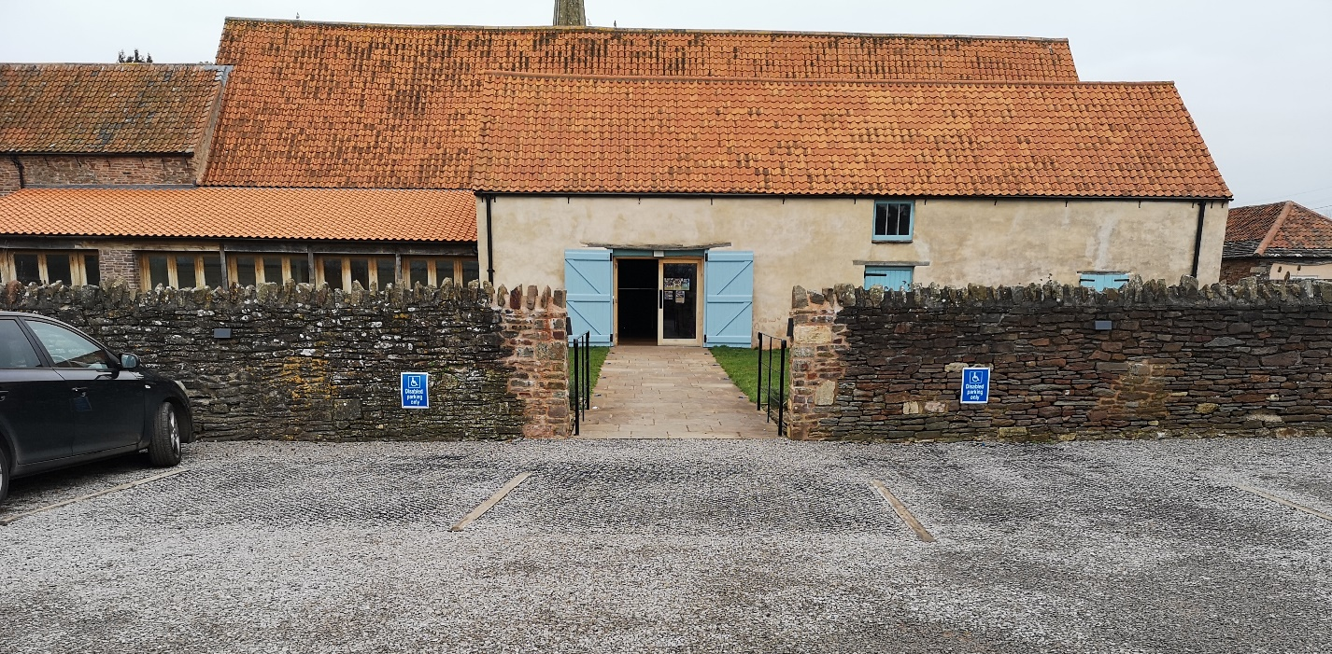
1 The accessible parking spaces and the entry route into the main barn
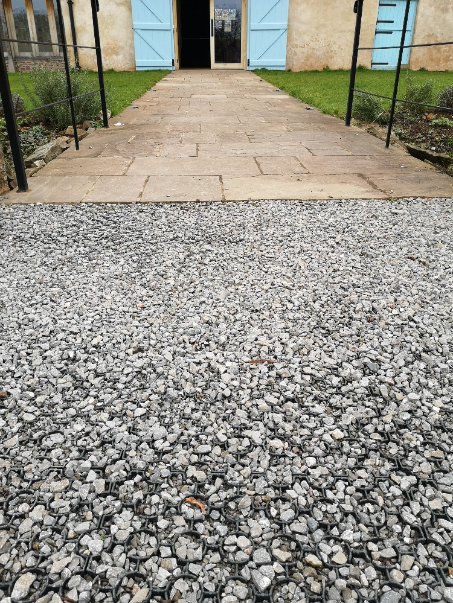
2 Detailed view of the gravel surface and the pathway
There is a car length of gravel (approximately 3m) car park, with plastic grid (bod pave) support under the gravel before reaching a paved pathway into the building. The pathway is slightly raised above the gravel (approximately 1cm). Vehicles with wheelchair access via a rear door can use the gap between the parking bays to drop off directly on to the path.
The pathway into the barn is lit with low level lighting that it turned on at night by a member of staff. The path is roughly 15m long.

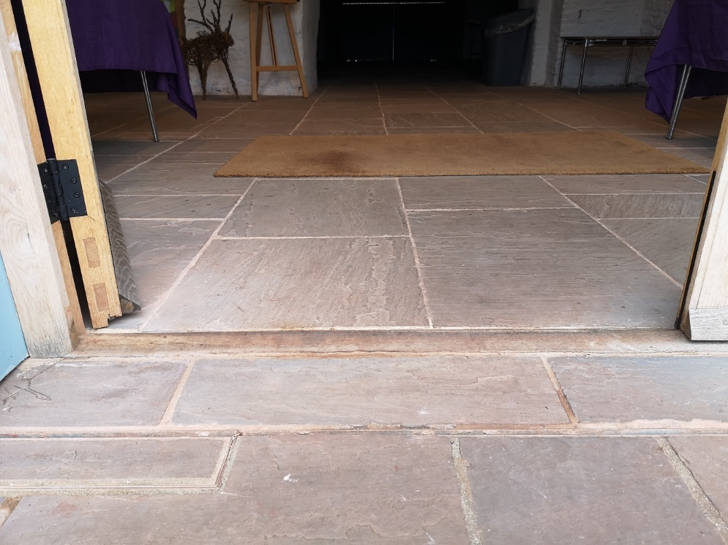
3 Detailed view of the main entrance threshold
There is a raised threshold into the building. It is ramped when entering the building, but there is a ledge when leaving. The threshold is 1.5cm in height. The doorway is 105cm wide. A second door can be opened to make the entryway 210cm wide.

Tickets are checked by a volunteer at a table next to the front door. They will ask your name, or the name your tickets were booked with, and check this off from a list of attendees. The entry way into the Main Barn is directly opposite the Main Entrance it does not have a door.
Team uniform is a purple t-shirt or black jumper with our logo on the left breast. Volunteers will have ‘VOLUNTEER’ written across the back, and any paid staff will have ‘TEAM’ written across the back in large letters.

Toilets and Baby Change
There is one accessible toilet, and two standard toilets on the ground floor.
The toilets are in the West Barn, which is accessed via a doorway to your left as you enter the building. The doorway is 108cm wide. Turn right at the end of the corridor. There is an opening to the West Barn. This opening is 100cm wide.
The accessible toilet is to the right on the other side of the opening. The standard toilets are further along the corridor to the left.
The door to the accessible toilet has a lever handle and opens outwards. The doorway is 77.5cm wide.
Baby change is also in the accessible toilet. The changing table can be removed and placed just outside of the toilet to improve access. You or a carer is welcome to do this, or a member of the team will also be happy to help.
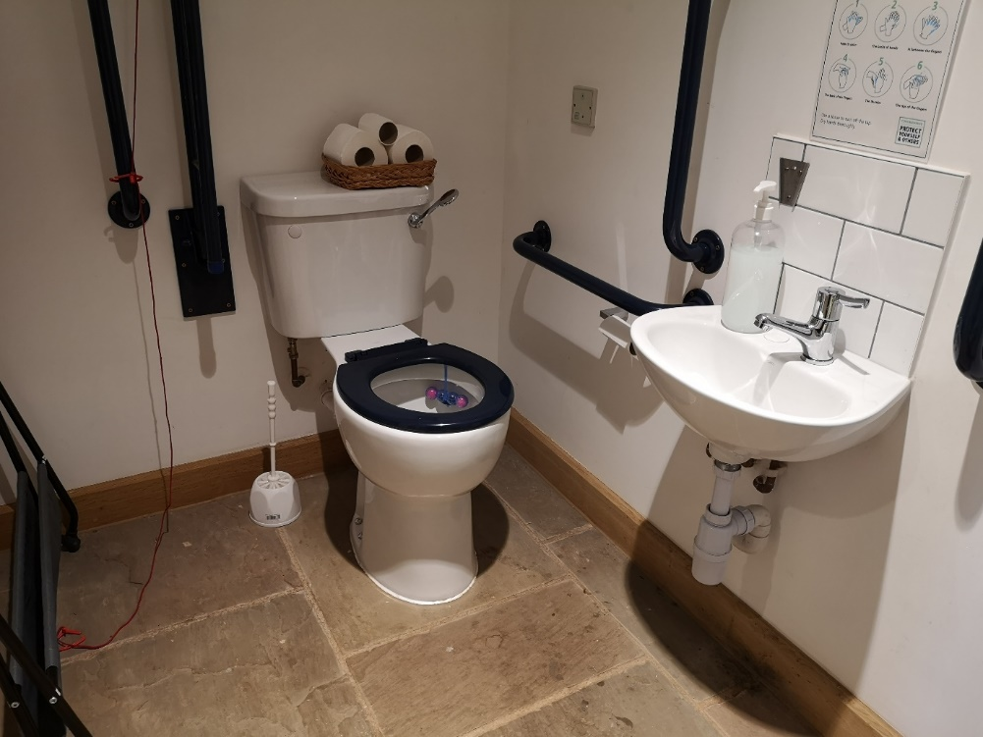
The accessible toilet is a shared toilet. You do not need a key to access the toilet. The door is locked by a lever lock. The door is light. The dimensions of the accessible toilet are: 148cm x 218cm, and the height of the toilet seat is 50cm.
4 Accessible toilet, sink, grab handles, and alarm cord.
There is a lateral transfer space. The transfer space is to the left as you look at the toilet. The transfer space is 80cm. A folding baby changing table is stored in the transfer space but it can be moved. There is a dropdown rail on the transfer side. The flush is not on the transfer side. There is an emergency alarm. There is not a coat hook. There is a large nappy/sanitary waste bin in the toilet.
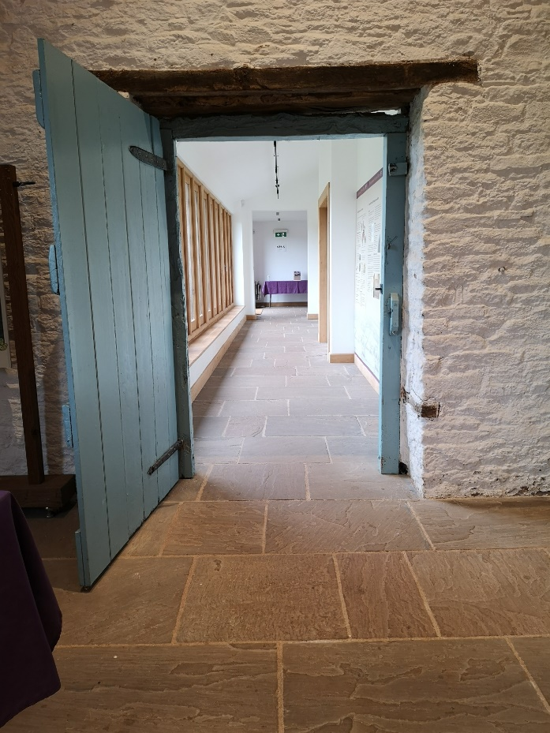
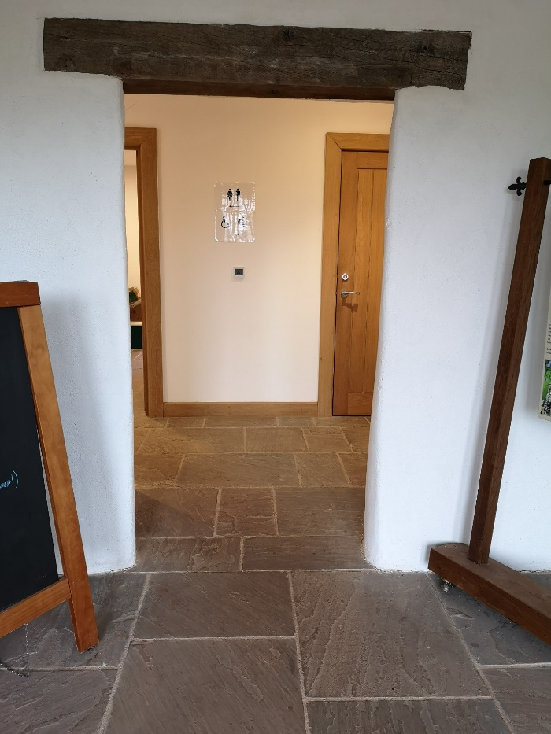
There are wall mounted grab handles on both sides of the toilet. There is no shelf in the toilet. There is a mirror and hand drier at a low height. The hand drier cannot be reached from the toilet.
5 Opening showing access route to the toilets. the closed door to the accessible toilet is visible on the right through the opening
6 Doorway showing access route to the toilets
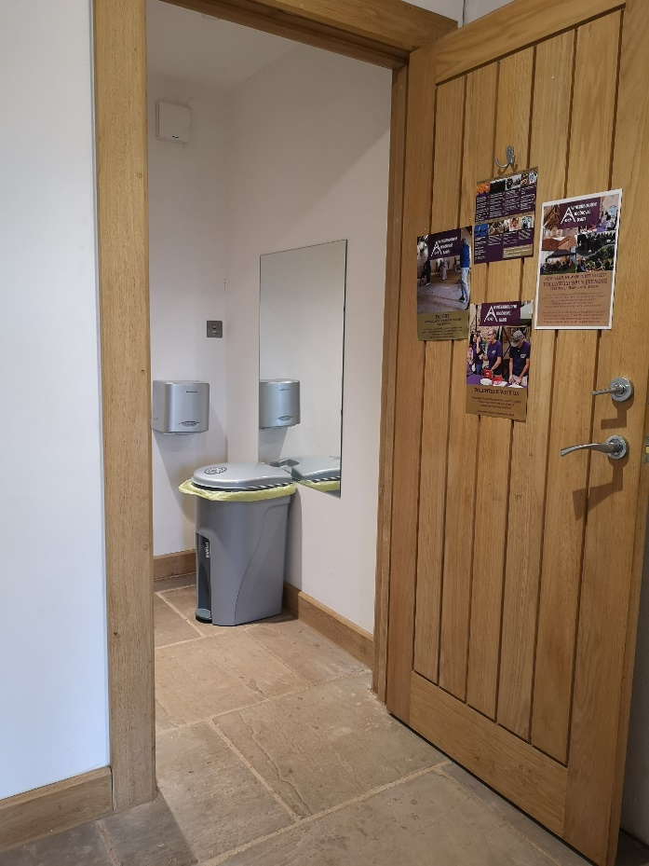
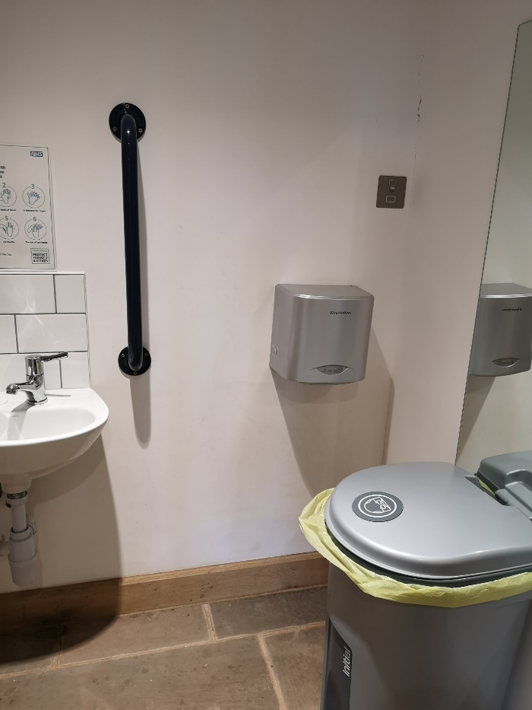
8 Detailed view of the sink, tap, grab handle, hand drier, and sanitary bin.
7 Entrance in to the accessible toilet showing the door open. A mirror, large sanitary bin, and hand drier are visible.

Other Areas and Facilities

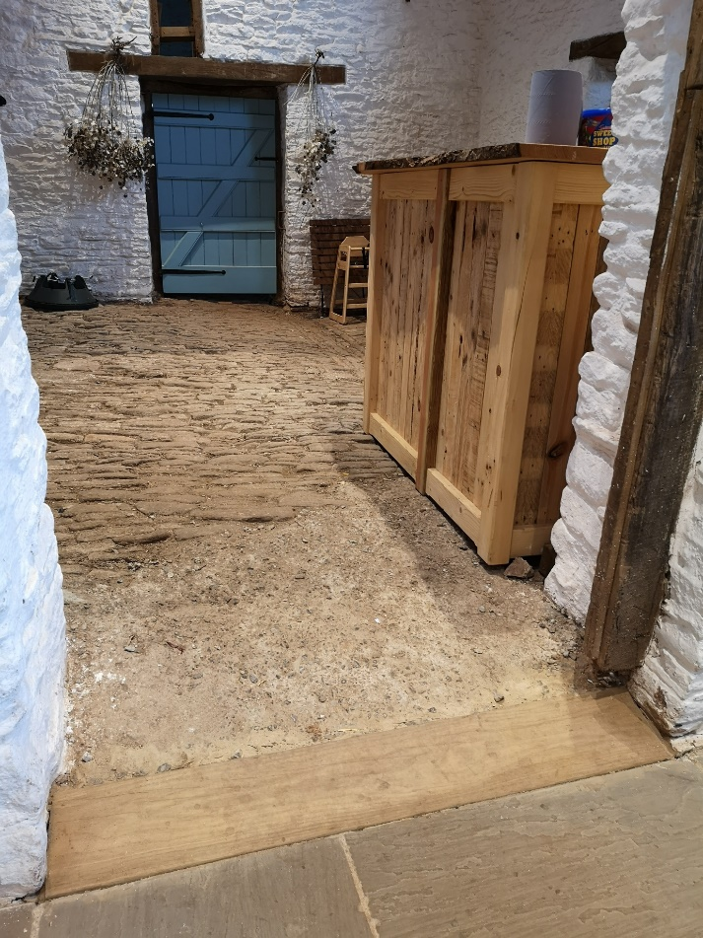
Bar
The Bar is located to the right of the main entrance and is not easily accessible. The room is accessed via a steep slope and the floor is very uneven. There is no dropped service point at the bar.
A member of the team will be happy to serve you at your seat, or from the foyer area.
We have a limited selection of wines, beers, and soft drinks. Any snacks served are individual wrapped with allergens printed on them.

Hearing Loop
The Main Barn is fitted with a hearing loop. The loop is always not active and is switched on for events. If you would like to use the loop we recommend you contact us in advance so we can ensure it is set up. Not all our volunteers are trained on how to use the loop.

Assistance Dogs
We are a dog friendly venue. We are happy to provide water for dogs. Your dog can toilet in the North Yard – waste must be removed from site, but a member of the team can direct you to a public dog waste bin. Please do not use any bins on site for dog waste except at very large events where a specific dog waste bin is provided on site.
9 View of the bar showing the entryway, bar, and cobbled floor

Access to Performance
Standard seats are 40cm wide and are not padded. You are welcome to bring your own cushion. A very limited number of wider seats are available on request.
Generally, performances will not have strobe or other lighting effects. In the unlikely event an event does include strobe lighting effects this will be signposted in the foyer.
While our events are all fairly informal, we do not generally offer relaxed performances. Any relaxed performances that we do hold will be clearly named in the event title.
We offer automated closed captioning for events that are available online via Zoom but are not able to offer this for events on site. Unfortunately, we cannot offer audio description of BSL interpretation.

